THE EASTER TRIDUUM:
The word Triduum, from the Latin triduum, means “three days.” The Easter Triduum is the most sacred period in the Church’s year, tracing the final moments of the life of Jesus Christ: His Passion, Death, and Resurrection. It begins at sundown on Maundy Thursday and concludes at sundown on Easter Sunday. These are not simply three separate days, but one continuous celebration of the Paschal Mystery, the summit of the Liturgical Year and the heart of Christian faith. Each part of the Triduum is marked by a distinct and profound liturgy.

HOLY THURSDAY – MASS OF THE LORD’S SUPPER
On Holy Thursday evening, the Church gathers to celebrate the Mass of the Lord’s Supper, commemorating the final meal Jesus shared with His disciples. During this meal, He revealed the depth of His love through humble service by washing their feet, giving a lasting example of charity and self-giving.
At this Mass, we celebrate the institution of the Eucharist, when Jesus offered His Body and Blood under the signs of bread and wine, commanding His disciples to “do this in memory of me.” On this same night, we also commemorate the institution of the ministerial priesthood, through which this sacred mystery continues in the Church.

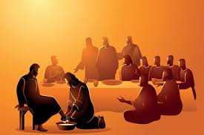

After Holy Communion, the liturgy takes a solemn turn. The Blessed Sacrament is carried in procession to the Altar of Repose, a place specially prepared away from the main sanctuary. This altar, often adorned with candles and flowers, represents the Garden of Gethsemane. Here, the faithful are invited to remain in silent adoration, keeping watch with Christ in His agony, recalling His appeal to the disciples to stay awake and pray. Meanwhile, the main altar is stripped bare. This stark gesture symbolises the abandonment of Christ by His disciples and prepares us for the austerity of Good Friday. Adoration at the Altar of Repose continues into the night, but does not extend beyond midnight, marking the moment of Christ’s arrest.

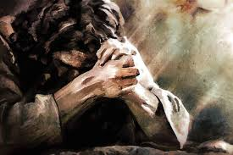

GOOD FRIDAY – THE PASSION OF THE LORD
Good Friday is a profoundly sacred day within the Easter Triduum, when the Church contemplates the Passion and Death of Jesus Christ on the Cross, a day of fasting, abstinence, silence, and deep prayer. Significantly, there is no Mass celebrated on Good Friday. The Mass is the sacramental making-present of Christ’s One sacrifice. Yet on this day, the Church does not celebrate the Eucharist, because she is invited to enter more directly into the mystery that the Eucharist makes present. Rather than celebrating the sacrament, we are drawn spiritually to Calvary itself. The Church stands in silence before the mystery of the Cross, entering into the Lord’s Passion with reverence and awe.
Instead, the faithful gather for the Liturgy of the Passion, which includes the proclamation of the Passion Gospel, the Solemn Intercessions, the Veneration of the Cross, (The faithful approach the Cross with reverence, acknowledging it as the instrument of Christ’s sacrifice and the means of our salvation. What was once a sign of shame has become the sign of victory and love) and Holy Communion from Hosts consecrated the previous evening. The altar remains bare, and the atmosphere is one of stark simplicity, reflecting the desolation of this sacred moment.

At the heart of this day lies a profound unity: the Cross and the Eucharist are one mystery. On Maundy Thursday, we celebrate the institution of the Eucharist; on Good Friday, we behold the sacrifice that the Eucharist makes present. In this way, the Church leads us not only to remember Christ’s death, but to enter into its saving power, uniting our own sufferings with His for the life of the world.
This day also invites us to reflect more deeply on suffering, both our own and that of the world. United with Christ, we bring before God the burdens of humanity, trusting in the redemptive power of His Passion.

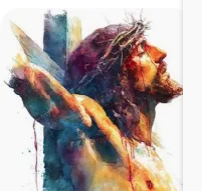

HOLY SATURDAY – THE GREAT SILENCE
Holy Saturday is marked by stillness and waiting. The Church remains at the tomb of Christ, contemplating His death and the sorrow of His disciples. It is a day without liturgical celebration until nightfall, inviting quiet reflection.The experience of the disciples is central here. They did not yet understand the Resurrection. They felt abandoned, disoriented, and filled with grief. This day speaks powerfully to moments in our own lives when God seems absent and hope feels distant.

EASTER VIGIL & EASTER SUNDAY – RESURRECTION
After nightfall on Holy Saturday, the Church gathers for the Easter Vigil, the most solemn and beautiful liturgy of the entire year. It begins in darkness, with the lighting of the Easter fire and the Paschal Candle, symbolising Christ as the Light who dispels all darkness.
Through Scripture, the Church recounts the history of salvation, leading to the proclamation of the Resurrection. The joy of the risen Christ breaks forth in the singing of the Gloria and Alleluia, which have been absent throughout Lent.
The Vigil celebrates Christ’s triumph over sin and death. It is the night when new members are welcomed into the Church through Baptism and Confirmation, sharing in the new life won by Christ.
This joy continues on Easter Sunday, as the Christian community gathers again to celebrate the Resurrection. The sorrow of the Passion gives way to the triumph of life.

THE HEART OF OUR FAITH
The Resurrection of Jesus Christ is not simply an event of the past. It opens a new destiny for all humanity. Christ has risen, never to die again, and we are invited to share in that same passage from death to life. Easter is not just one feast among many. It is rightly called mother of all vigils” and the high point of the liturgical year,” just as the Eucharist is known as “the Sacrament of Sacraments.” Everything in the Church’s life flows from and returns to this mystery.

THE SACRAMENT OF CONFESSION:
The Church uses several names for this sacrament because each highlights a different grace. It is called Confession because we acknowledge our sins; Penance because we express repentance and conversion; and Reconciliation because it restores our friendship with God and the Church (CCC 1422–1424).
The Church teaches, in the Catechism of the Catholic Church, that this sacrament was instituted by Christ Himself. After His Resurrection, Jesus Christ breathed on His disciples and said: “Receive the Holy Spirit. Whose sins you forgive are forgiven them” (cf. Gospel of John 20:22–23). Forgiveness of sins is therefore not only a private prayer, but a gift entrusted to the Church.
Scripture continually calls us to conversion. Jesus proclaims: “Repent, and believe in the Gospel” (cf. Gospel of Mark 1:15), and assures us that God is always ready to forgive (cf. First Letter of John 1:9).
Why go to Confession?
Because sin wounds our relationship with God and others. Through this sacrament, God offers:
- Forgiveness of sins
- Peace of conscience and spiritual healing
- Strength to resist future temptation
- Restoration of grace and deeper union with God (CCC 1468–1470)

How often should we go?
The Church gives both a minimum obligation and a loving encouragement:
- At least once a year: Every Catholic who has reached the age of reason must confess serious sins at least once a year (CCC 1457).
- After serious sin: If we are conscious of mortal sin, we should go to Confession as soon as reasonably possible, especially before receiving Holy Communion.
- Frequently as a grace: Even when not strictly required, regular confession (for example monthly) is strongly recommended, as it helps us grow in holiness and strengthens our spiritual life (CCC 1458).
Confession is not only a duty, but a gift. The best time to come is when we recognise our need of God’s mercy.
A word about past experiences
Some may hesitate because of past experiences. Perhaps, years ago, you encountered a priest who seemed harsh or unkind, and the memory has stayed with you. That experience is real and may have discouraged you. Yet the sacrament is not about the personality of the priest, but about the mercy of Christ. The Church today strongly emphasises compassion, patience, and understanding in the confessional. Do not let a difficult experience keep you away from the healing Christ desires to give you.

No sin too great
Many also stay away because of fear, shame, or the thought: “It has been too long.” But the truth remains: no sin is too great to be forgiven, and no one is beyond God’s mercy. Whether it has been months, years, or even decades, the Lord is always ready to welcome us back, like the father in the parable of the prodigal son (cf. Gospel of Luke 15:11–32).

What to expect
Confession is a simple and grace-filled encounter. The priest is there not to judge, but to act in the person of Christ. You may begin by saying how long it has been since your last confession. You confess your sins honestly, receive gentle counsel, accept a penance, and hear the words of absolution, through which Christ Himself forgives you.

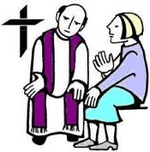
EASTER CONFESSIONS:
Priests will be available to hear Easter Confessions at the following times:
Good Friday: 3 – 5pm
Holy Saturday: 10am – Midday (12)

JESUS’ CROSS AND OUR CROSSES:
It is customary during the Good Friday Solemn Liturgy to venerate the Holy Cross. We come forward, kneel or bow, and kiss or touch the Crucifix as a sign of our love, gratitude, and reverence for our Lord in His Passion. Each of us carries crosses in our daily lives. These may take the form of illness, grief, loneliness, worry, regret, fear, or a deeper sense of woundedness.
This Good Friday, we are invited to unite our personal crosses with the Cross of Christ in a simple and meaningful way. Parishioners are kindly asked to make a small cross from paper or card. It may be left plain or decorated with words, prayers, or colour.
As you come forward to venerate the Cross, you are invited to bring your small cross and place it in the baskets prepared in the sanctuary. In doing so, we symbolically offer our burdens to the Lord, saying in our hearts: “Lord Jesus, I offer You the cross I carry. I unite it with Your saving Cross and ask for Your healing, strength, and grace.”
Please try to prepare your simple cross in advance and bring it with you on Good Friday.

GOOD FRIDAY COLLECTION:
Each year on Good Friday, the Church invites us to take part in the Collection for the Holy Places, a gesture strongly encouraged by the Holy See. This collection supports the Christian communities of the Holy Land, often called the “living stones,” and helps maintain the sacred sites entrusted to the care of the Franciscan Custody of the Holy Land. As the Vatican reminds us, this is not only about preserving buildings, but about sustaining a living Christian presence in the land where our Lord lived, died, and rose again. In a time of great hardship for many in that region, your generosity becomes a powerful sign of solidarity, faith, and charity flowing from the Cross of Christ.

CHRISM MASS:
The Chrism Mass is a special liturgy during Holy Week, usually on Holy Thursday morning (here in Southwark on Holy Wednesday). It is celebrated by the diocesan bishop with priests, deacons, religious, and lay faithful of the diocese.
During this Mass, the bishop blesses the holy oils used throughout the year in the sacraments:
- The Oil of Catechumens (for those preparing for Baptism)
- The Oil of the Sick (for those who are ill or elderly)
- The Sacred Chrism (used in Baptism, Confirmation, and Ordination)
The Chrism Mass also offers priests the opportunity to renew their priestly promises in the presence of the bishop and the faithful, highlighting the unity of the clergy with their bishop and the communion of the Church.
For the faithful, attending or learning about the Chrism Mass reminds us of the sacraments’ ongoing presence in our lives and the bishop’s role as a shepherd guiding the spiritual life of the diocese.
USE OF HYMN BOOKS & MISSALS:
Each pew is provided with a designated number of Sunday Missals and Hymn Books for the use of those seated in that particular pew.
Parishioners are kindly asked:
- Not to move or remove these books from their assigned pew
- To leave them neatly and carefully in their designated place after Mass
- To ensure that children do not play with or damage them
These books are the property of the parish community and are intended solely for use IN THE CHURCH.
Your cooperation is greatly appreciated in helping to maintain them in good condition for the benefit of all.



USE OF CANDLES

DURING EASTER SERVICES:
During the celebration of Easter, and in accordance with current safety and security regulations, the use of open flame candles by the congregation is not permitted. The only lit candle will be the Paschal Candle, which symbolises the light of Christ and will be used in the liturgy as prescribed. To enable full participation in the Easter Vigil, the parish will provide LED candles for use during the procession, while seated in the pews, and at the renewal of baptismal promises. We kindly ask that these candles are returned at the end of the service. We appreciate your understanding and strict adherence to these guidelines, which are in place to ensure the safety of all while preserving the dignity and beauty of the liturgical celebration.

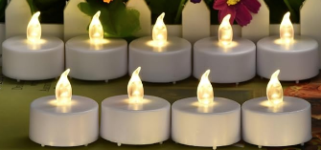

LEARN MORE ABOUT THE CATHOLIC FAITH:
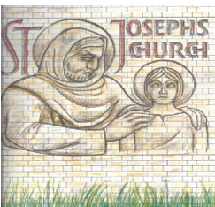
ST JOSEPH’S CATHOLIC CHURCH – 218 ROEHAMPTON LANE SW15 4LE
Parish Email: roehampton@rcaos.org.uk Tel: 020 8788 5012
Parish Priest: Fr Louis Adjétey Kouevi mccj Email: louiskouevi@rcaos.org.uk
Assistant Priest: Fr Gordon Rees mccj Email: gordonrees@rcaos.org.uk
Pastoral Assistant: Sr Nora Coughlan smg Email: nora.coughlan@psmgs.org.uk
Safeguarding Rep: Ms Sarah Mendy
Parish Secretary:

Website:
YouTube : Facebook: facebook.com/stjoseph.roehampton

Are you curious about the Catholic faith or wish to deepen your understanding of what Catholics believe and practise? Perhaps you are discerning whether God may be calling you to become a Catholic or you or a family member are looking to be prepared to receive a Sacrament such as Baptism, Confirmation, or First Holy Communion.

Helpful Apps to Explore the Faith
Some useful apps for prayer and learning include:
• Laudate – prayers, daily readings, and the Catechism
• Hallow – guided prayer, meditation, and Scripture reflections
• Universalis – daily Mass readings & Liturgy of the Hours
• www.catholicevents.co.uk – Find and stay connected to your Catholic Community; Discover Retreats, Talks & Events near you
PALM SUNDAY – YEAR A
“Blessed is he who comes in the name of the Lord! Hosanna in the highest.”

For Readings see next to the specific day in Holy Week Programme (here below)
The Order of Mass: See from page 449 in Sunday Missal

• www.rcaos.org.uk/ambassadorsforchrist – weekly evidence-based answers to common questions about the Catholic faith

CHURCH OFFERINGS & DONATIONS:
For weekly offerings or donations via our Bank, please use the following Account (and specify who is the beneficiary of your offering). Thank You!

Bank Name: NatWest
Account Name: RCAS ROEHAMPTON
Account Number: 11716401
Branch sort code: 60-07-20

Those who are in the GIFT AID scheme and wish to give their donation online should make use of the following account number:
Bank Name: NatWest
Account Name: RCAS ST JOSEPH - COVENANT INCOME ACCOUNT - ROEHAMPTON
Account Number: 11732709
Branch sort code: 60-07-20

CARD MACHINE:
A card machine is available at the back of the church. Please follow the on-screen instructions. Donations can also be made from your phone using this QR code.
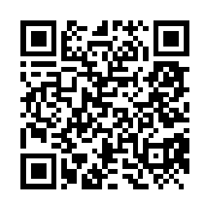

MASS INTENTIONS:
To request a Mass intention, please take a dedicated envelope from the back of the church, complete it, and return it to a priest or the Parish Office. You may also select “Mass Intention” on the card machine. The diocesan suggested offering is £10. This is not a fee, but a voluntary offering given in support of the priest and the mission of the Church.
ROEHAMPTON UNIVERSITY CHAPLAINCY:

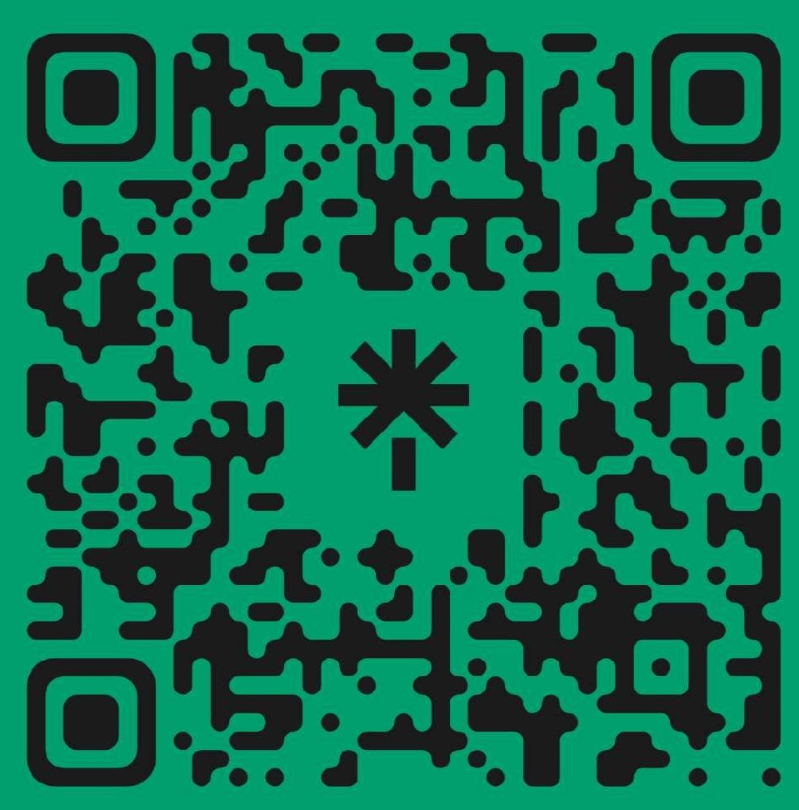

For more information about Sacrament preparation courses, RCIA, please contact one of the priests or the parish office.

PROGRAMME FOR HOLY WEEK 2026:

PALM SUNDAY (29 MARCH): Missal Page: 153
Saturday Vigil 6pm People of the Parish

Sunday Masses:
9am: Caterina’s & Christopher’s Intentions
11am Michael McCrudden (7th Anniv) & Joe Keany (40th Anniv) RIP
6pm Hema Gunasekara RIP

Monday 9.30am Personal Intentions

Tuesday 9.30am Personal Intentions

Wednesday 9.30am Personal Intention
11.30am Chrism Mass at St George’s Cathedral

MAUNDY THURSDAY (2 APRIL): Missal Page: 194
NO MORNING MASS
7.30pm Mass of the Lord’s Supper
Followed by Silent Adoration at the Altar of Repose

GOOD FRIDAY (3 APRIL): Missal Page: 203
NO MASS TODAY

12:30pm WALK OF WITNESS - Way of the Cross organised by the Christian Churches of Roehampton, starting from the Minstead Gardens (Methodist Church).

3pm Passion of Our Lord (with Confessions & Communion)

The Church will remain open 7.30pm for Silent Private Prayer

HOLY SATURDAY (4 APRIL): Missal Page: 228
NO MORNING MASS
9pm Easter Vigil Mass People of the Parish

EASTER SUNDAY (5 APRIL): Missal Page: 271
9 & 11am Mass of the Resurrection
9am: Raionda Valiukeviciute RIP
11am: Birthday blessings & thanksgiving for God’s mercy
NO EVENING MASS

EASTER CONFESSIONS:
Priests will be available to hear Easter Confessions at the following times:
Good Friday: 3 – 5pm
Holy Saturday: 10am until Midday (12)

WE PRAY FOR THE ETERNAL REST OF:
Hema Gunasekara, Jojo Gomez, Amandus Kalombo, John O’Connor, V. Coker Appiah, Thomasina Pereira, Pius Adiboye, Antonia Ajiboye, Ricardo Santiago, Isabella Vecino, Johanita Dogbey, James, Chris O’Reilly, Ellen Cliff, Darren Brady, Leyland Phillips, Christine Doyle, Flaviana, Paul Bahoshy, John Corcoran, David Coughlan, Stanley Lassow, Esther Whelan, Michael Dundon, Fr Jake Dicto, Mary Kilderry, Nick Murphy, Malcolm Mitchell, Shiela Brady, Majorie Chapman, Hanna Okyere, Albert Mensakane, Jeannette Said, Frieda Bradbury, Honorio Aquillano, Antonio Remorin, Jean-Luc Viart, John Brazil, Nanda Gunasekara, Anne Murphy, Helen Iwo, Reena George, Anthony Adansi, Jovencio Domingo, Teresa Ryan, Clair Moore

WE PRAY FOR OUR SICK:
Abdalla Khadra, Alison Conte, Amduth Lallbeharry, Bridget Gordon, Caroline Ighodaro, Caterina Goodhart, Catherine Corcoran, Chris Chrystal, Debbie Alexander, Denise & Fabrizio Panattoni, Dolores Sears, Erlinda Turnbull, Ernest Osei, Florisa Di Valentino, Genevien Destot, James Tackie, Jeanne Smith, Len & Ray McCabe, Mary Clayson, Mary Newman, Myra Young, Nathalie Williams, Rory Bajdan, Zuzana, Mary Masterson, Michael Tyler, Mary Crassweller, Richard, Joana de Paula, Barry Smith, Danusia Mytko, Cordelia Alexander, Orleen McIntosh
Get in touch – scan the QR code and click the WhatsApp link.

Catholic Chaplain: Dan Williamson
Tel: 07825012385
Email: Daniel.Williamson@roehampton.ac.uk

